Ramsha Bilal

Problem Set 4

bilal_week4_ps

Debugging record

PC

**Debugging Problem Set 4**

**Note: Some debug versions are commended out when using pointers so that the pointer points to the start location when returned. (in extra credit Substring function, same values are passed as in the first function)**

**Case Number 1:**

**(c) Problem 1** – object is assigned 65 cents and 2 dollars already. Parameters passed to addMoney() are 75 cents and 3 dollars.

**Problem 2 –** parameter passed to substring are (word, 3, 4). (Passed as constants).

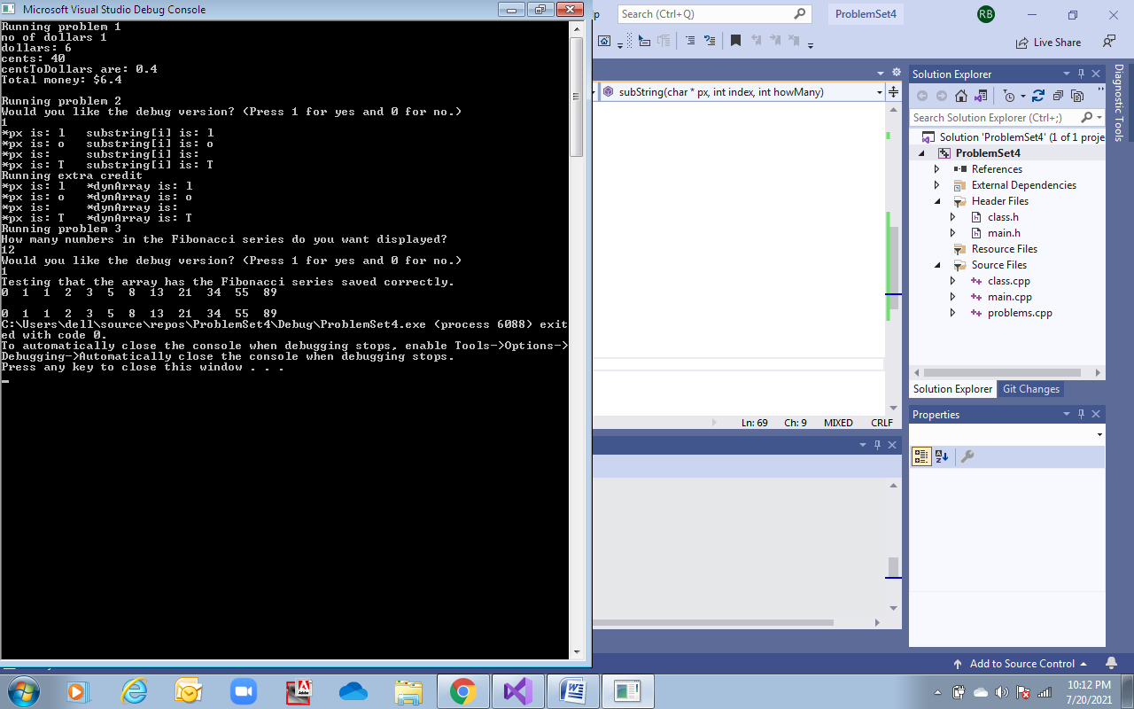

**Problem 1** – object is assigned 65 cents and 2 dollar already. Parameters passed to addMoney() are 35 cents and 12 dollars.

**Problem 2 –** parameter passed to substring are (word, 3, 99). (Passed as constants).

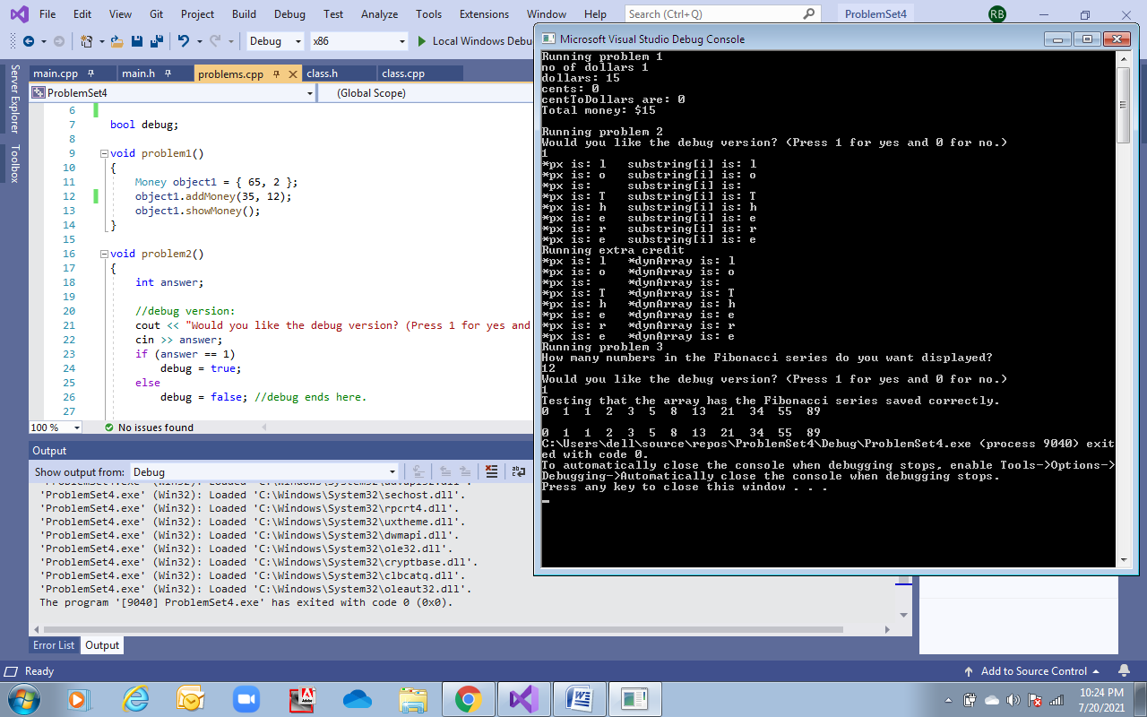

**Problem 1** – object is assigned 65 cents and 1 dollar already. Parameters passed to addMoney() are 120 cents and 0 dollars.

**Problem 2 –** parameter passed to substring are (word, 3). (Passed as constants).

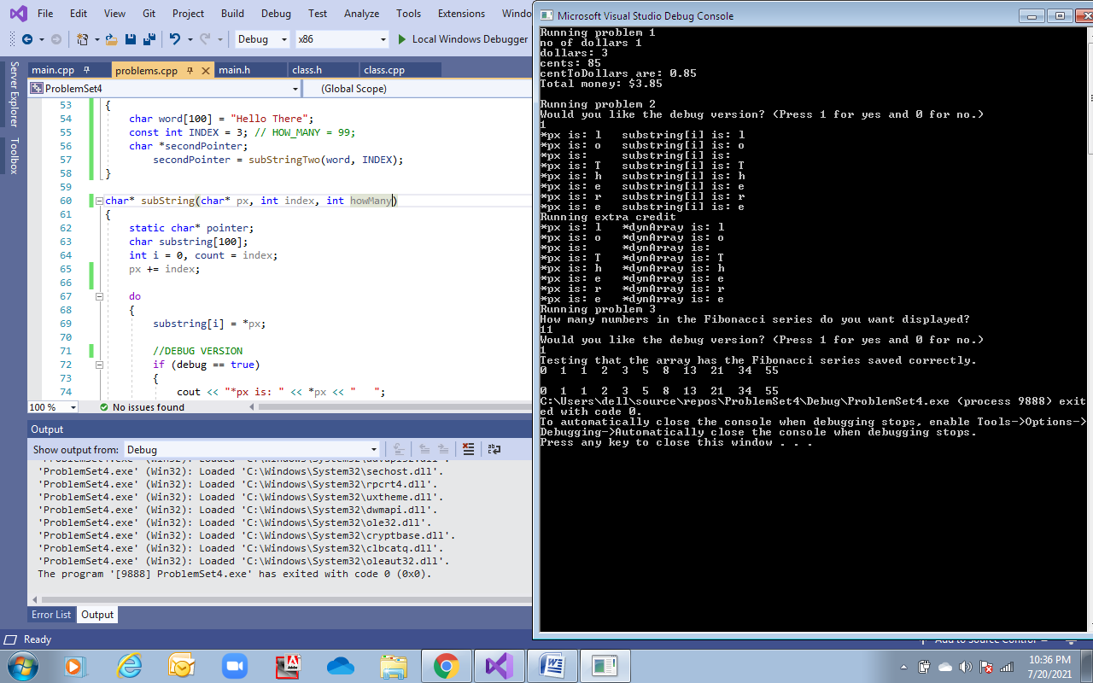

**Problem 1** – object is assigned 65 cents and 1 dollar already. Parameters passed to addMoney() are 120 cents and 0 dollars.

**Problem 2 –** parameter passed to substring are (word). (Passed as constants).

DISPLAYS ERROR.